**Image Captioning**

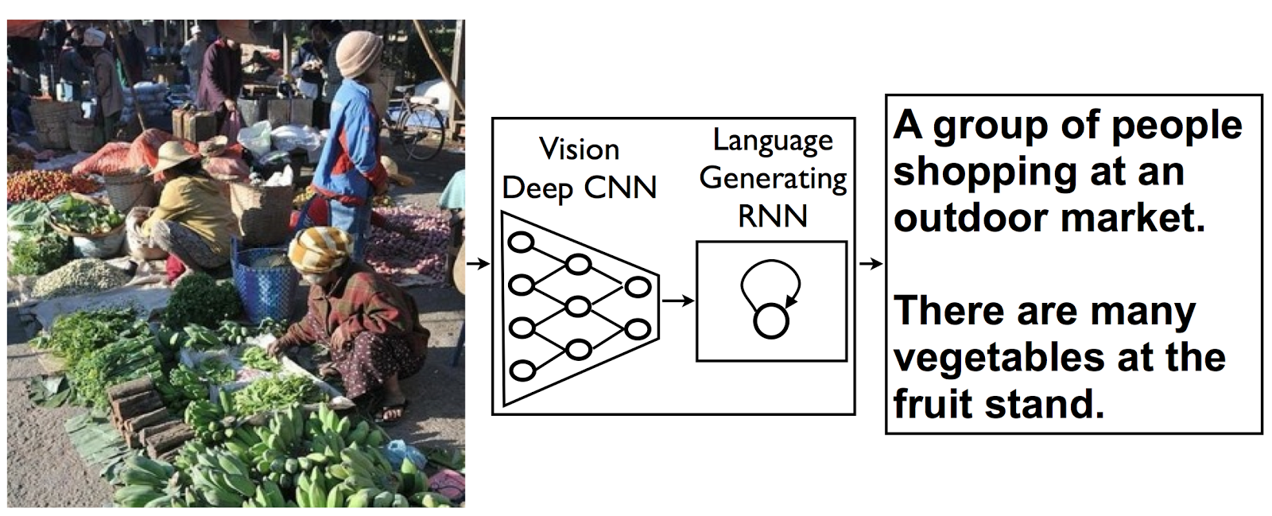

Refrences :

1. Show and Tell: A Neural Image Caption Generator [[1](https://arxiv.org/pdf/1411.4555.pdf)]
2. Google AI Blog [[2](https://ai.googleblog.com/2014/11/a-picture-is-worth-thousand-coherent.html)]